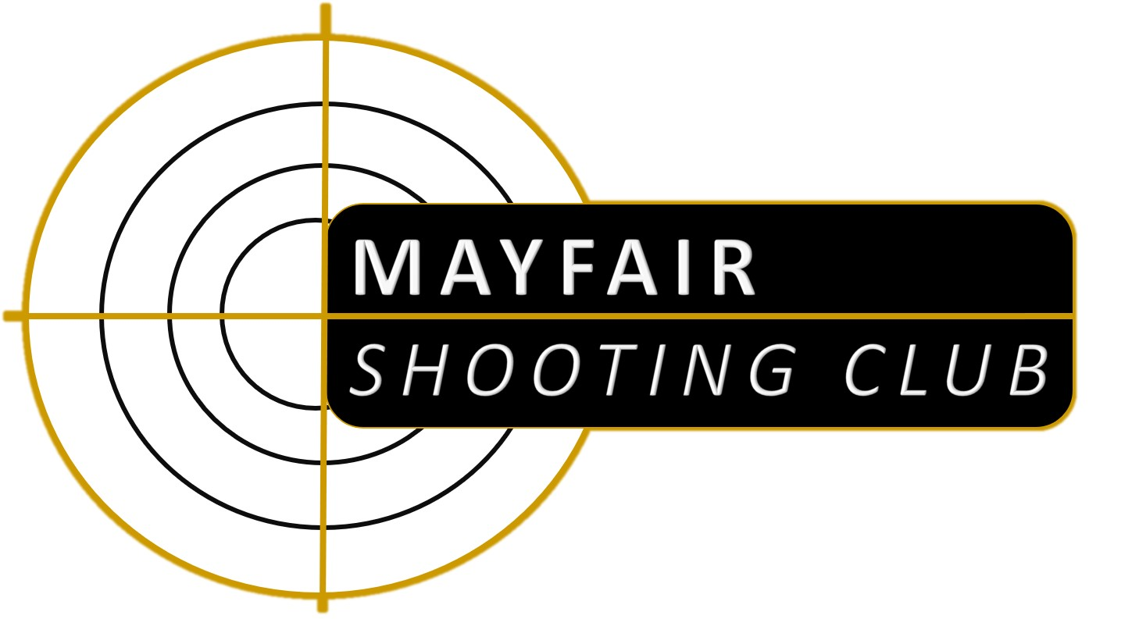
MAYFAIR BUILDINGS
DURHAM ROAD
SUNDERLAND
SR2 7PD

019 1564 1966

mayfairshootingcentre.co.uk
info@mayfairshootingcentre.co.uk

Dear prospective member,

With reference to club membership, our annual subscriptions are as follows:

Individual Membership
Adult (18yrs or over) - £155
Family Membership
(All residing at same address)
First Adult; - £155 + Spouse/Partner and/or additional adult(s) under 21yrs. of age - £90
Child under 18yrs of an adult family member (residing at same address or not) - £40
We make a one-off £25 charge to cover our admin and instructor’s time during your safety instruction
The club membership year runs from 1st August to the 31st July. All applicants pay the full fee and receive a pro-rata renewal in August. So, if you join, 6 months into the membership year you will pay a 50% renewal fee at renewal time (August) which will bring you onto the same renewal cycle as existing members.

In all cases the cost may be spread over a number of weeks, please ask for details. There are no additional range fees and after completion of your instruction you may use the facilities as often, and for however long you wish, subject to the opening times below. The only on-going costs are the gun hire, ammunition and targets you use.

We are a Home Office Approved Club and which means that we can welcome new starters with no previous experience who will undergo a safety and handling course which can usually be arranged during any of our opening hours. There is a SIX month probationary period before new starters can apply for a certificate to purchase their own firearms (three months where proposed by an existing member), but in the meantime we have a variety of club firearms to use.

We welcome young shooters. People who are under 18 must join with a parent or guardian who must supervise them at all times when handing firearms or ammunition and whenever they are on the premises.

At our range we can use a wide variety of firearms; we keep bolt action and semi-automatic rifles in .22 rim-fire and .357 and .44 lever action rifles as club guns. Muzzle-loading firearms (pistols and rifles) and long-barrelled cartridge pistols and revolvers can also be used by members who have them on their personal certificates after additional instruction and qualifying. Our sister club, Tyne Valley Rifle Club, has access to military outdoor ranges, principally Ponteland, for distances up to 600 metres.

No other club in the North East has anything like as much range time available. We also have our own range for ‘Practical Shotgun’.

We have enclosed an application form and declaration which MUST be completed before your application can proceed. Please note: you must give details of two referees unless being proposed by an existing member.

It is a requirement that Home Office approved clubs provide the details of all membership applications (including your completed form and ID documents if requested) to the police firearms licensing department.

WE REQUIRE TWO FORMS OF OFFICIAL IDENTIFICATION SUCH AS A PASSPRT OR DRIVING LICENCE. ONLY ONE IS REQUIRED IF IT SHOWS YOUR ADDRESS. ALL NON-UK CITIZENS MUST PROVIDE A PASSPORT ISSUED BY THE COUNTRY THEY ARE DECLARING THEMSELVES TO BE A NATIONAL OF. WE WILL RETAIN SCANS OF THESE DOCUMENTS DURING YOUR MEMBERSHIP

Yours faithfully,
Mayfair Shooting Centre. Opening Hours
WEEKDAYS DAYTIME EVENING
Tuesday 10.00 - 11.00 Shop only 11.00 - 4.00 Shop and range 6.30 - 9.00 Shop and range
Wednesday 10.00 - 11.00 Shop only 11.00 - 4.00 Shop and range 6.30 - 9.00 Shop and range
Thursday 10.00 - 11.00 Shop only 11.00 - 4.00 Shop and range 6.30 - 9.00 Shop and range
Friday 10.00 - 11.00 Shop only 11.00 - 4.00 Shop and range 6.30 - 9.00 Shop and range
WEEKENDS Saturday 10.00 - 4.00 Shop and range & Sunday 10.00 - 1.00 Shop and range
Please note, last entry onto the range is 30 minutes before the end of any session
© North Britain Shooting & Events Ltd
MAYFAIR BUILDINGS
DURHAM ROAD
SUNDERLAND
SR2 7PD

019 1564 1966

mayfairshootingcentre.co.uk
info@mayfairshootingcentre.co.uk
Application for Membership

Full Name:_________________________________________________________________________

Address(inc postcode):________________________________________________________________

Tel No: Mobile No___________________Email:_______________________

D.o.B:______________Occupation:____________________Nationality:________________________
Have you lived outside the UK at any time within the previous five years? YES/NO
If so give details overleaf (eg; where, when, for how long)

Are you a member, or have you ever been a member of any gun club? YES/NO
If yes, give details overleaf, and, if applicable, the reason for leaving

Do you hold a Firearm Certificate? YES/NO

If yes give FAC No:_______________________________Police Area:_________________________________
Do you hold a Shotgun Certificate? YES/NO

If yes give SGC No:_______________________________Police Area:_________________________________

Have you ever had a Firearm or Shotgun Certificate revoked or been refused
the grant or renewal of one? If yes give details overleaf YES/NO

Have you ever been convicted of any offence in any country?
If yes give details overleaf YES/NO

Do you know of any reason why you would be prevented from obtaining
a Firearm Certificate? If yes give details overleaf YES/NO
---------------------------------------------------------------------------------------------------------------------------------------------------
I understand that my subscription is not refundable if I fail to retain, for whatever reason, full or probationary membership.
I understand that the details of this application will be provided to the police, as per the conditions of the clubs’ Home Office Approval.

I (Name) wish to apply for membership, and DECLARE that I am not prohibited from possessing a firearm or ammunition by virtue of section 21 of the Firearms Act 1968

Signed: Date:

(We accept payment of membership fees by cash or bank transfer ONLY)

--------------------------------------------------------------------------------------------------------------------------------------------------------------------------------------------------------------
Proposed by Print Name:_____________________________Signed_________________________

Please tell us how you heard about us

© North Britain Shooting & Events Ltd

